**Vision and Scope Document**

**For**

**E-Learning Platform**

**Prepared by**

**Mishal Mazhar(4473)**

**Submitted to: Mam Saba Taimouri**

**Date:14 May 2024**

# 

Contents

**1. Business requirements** 3

**1.1 Background:** 3

**1.2 Business Opportunities:** 3

**1.3 Business Objectives:** 3

**1.4 Success Metrics:** 5

**1.5 Vision Statement:** 5

**1.6 Business Risk:** 6

**1.7 Business Assumptions:** 6

**2. Scope and Limitations** 6

**2.1 Major Features:** 6

**2.2 Scope of initial release** 8

**2.3 Scope Of Initial And Subsequent Releases** 9

**2.4 Limitations and exclusions** 9

**3. Business Context:** 10

**3.1 Stakeholder Profiles:** 10

**3.2 Project Priorities:** 10

**3.3 Deployment Considerations:** 11

# **1. Business requirements**

# **1.1 Background:**

The e-learning platform which we are launching in response to the changing environment of education and training, aims at developing new platforms for e-learning. These are developed to address issues that students and teachers face when accessing quality education, monitoring progress, enhancing communication, and conducting evaluations. This course on e-learning focuses on course management, student progress tracking, communication and collaboration, assessment and grading as well as certification management. The way people learn, and organizations train their staff will be transformed by this online learning course. Through technology driven methods for modern educational challenges it will help facilitate personalized interactive meaningful learning for learners wherever they may be.

This online platform is designed to meet the needs of a wide range of users including students looking for quality education providers, teachers who want to deliver courses online or manage training programs. The goal of the platform is to democratize access to quality education while promoting leadership in lifelong learning through an all-inclusive system tailored towards accommodating various requirements from both educators’ and pupils’ points of view.

# **1.2 Business Opportunities:**

Our e-learning platform offers great business opportunities by solving common problems in both corporate training and commercial education. It simplifies course management and helps track how well employees are doing. It also allows people to communicate and work together better, and evaluate how well they're learning. They also ensures that everyone has the most up-to-date training by maintaining their certifications. In the business world, our platform competes by being easy to use and offering features that make online learning more effective. It's great for anyone looking to learn or teach something new, it makes learning easier and fun .By fixing issues like hard-to-access resources and inefficient training methods, our platform stands out as a solution that makes learning easier.

# **1.3 Business Objectives:**

Financial:

1. Increase the number of active users using the e-learning platform by using marketing plans, user-friendly relationship, and promotional campaigns to attract new users and retain existing ones.
2. Increase revenue by offering a variety of subscription plans, courses, and value-added services to meet a diverse customer base. Use discount strategies and promotions to encourage users to upgrade their list and register additional courses.
3. Maximize return on investment by optimizing business processes, reducing administrative costs, and improving performance in classroom management, student tracking, communication, and assessment. Monitor key performances regularly to monitor progress and adjust strategies as needed to achieve the desired return on investment.
4. Form partnerships with educational institutions, corporate customers and stakeholders to expand the platform's reach and support users' products. Work with partners to create content, develop solutions, and implement marketing strategies to attract new users and increase revenue.

Nonfinancial:

1. Continue to improve the user interface and navigation of course management to make it easier to understand and use. Providing tools to easily create, organize, and edit content allows teachers to create a collaborative and effective learning environment for students.
2. Enable students to get work done so they can always keep a good track of their progress and performance. Provide visual dashboards, progress reports, and personalized lessons to support student learning and engage in their learning journey.
3. Improve the learning environment through communication and collaboration directly on the platform. Allow students to communicate with teachers and classmates, participate in group discussions, and collaborate on projects and real-time projects.
4. Improve assessment and grading to save teachers time and effort while being accurate and fair. Provide tools to create and manage assessments, grade assignments, and provide timely feedback to students. Use functions such as automatic scoring, test scores, and peer review to increase efficiency and effectiveness.
5. Create a certification management system to simplify reporting, tracking and management of the certification process. Provide teachers and administrators with tools to create and distribute certificates, track student achievement, and verify certificate authenticity. Ensure compliance with industry standards and regulations to ensure the integrity and reliability of certificates issued by the platform.

# **1.4 Success Metrics:**

**Constructor**

SM-1: 80% of instructors who use the platform for at least 3 courses per semester will use the platform's communication tools for at least 75% of their courses within 6 months following initial release.

SM-2: The average rating on the instructor satisfaction survey increases by 0.5 on a scale of 1 to 6 from the pre-implementation rating within 3 months following initial release and by 1.0 within 12 months.

**Learner**

SM-1: 75% of learners who enroll in at least 2 courses per semester will complete at least 90% of their courses within 6 months following initial release.

SM-2: Within three months after the initial release, the average rating on the learner satisfaction survey is expected to increase by 0.5 on a scale of 1 to 6 from the pre-implementation rating, and within 12 months, it is expected to increase by 1.0.

**Administrator**

SM-1: Within six months of the initial release, it is expected that 90% of administrators will observe a decrease of at least 25% in support queries and issues.

SM-2: The average rating on the administrator satisfaction survey increases by 0.5 on a scale of 1 to 6 from the pre-implementation rating within 3 months following initial release and by 1.0 within 12 months.

# **1.5 Vision Statement:**

For instructors, learners, and administrators seeking for a seamless and inclusive online-learning experience, the E-Learning Platform is a cutting-edge, Internet-based, and smartphone-compatible application. It will welcome both individual or group course enrollments, monitors student progress, facilitate communication and collaboration, enable efficient assessment and grading, and manage certification processes. Unlike traditional learning methods, the E-Learning Platform will not require learners to be physically present in a classroom, saving time and expanding their access to a wide range of courses and learning resources.

# **1.6 Business Risk:**

RI-1: Instructors might resist adopting the new platform, requiring additional training and support resources.

RI-2: There's a chance that course enrollment may fall short, resulting in a reduced return on investment from platform development and marketing efforts.

RI-3: Technical issues might occur, leading to system downtime and potentially affecting learner engagement and satisfaction negatively.

RI-4: Insufficient bandwidth and infrastructure might hinder the platform's performance, leading to slow loading times and decreased user experience.

RI-5: Competitors might launch similar e-learning platforms, attracting learners and instructors away from our platform.

# **1.7 Business Assumptions:**

AS-1: Users will have access to stable and reliable internet connections to interact with the e-learning platform seamlessly.

AS-2: Adequate technical support personnel will be available to address any user inquiries or technical issues promptly.

DE-1: Integration with existing learning management systems (LMS) must be established to enable seamless data exchange and course synchronization between platforms.

# **2. Scope and Limitations**

# **2.1 Major Features:**

**Course Management (FE-1):**

* Students can browse and enroll in available courses.
* Instructors can create, manage, and customize course content.
* Administrators can oversee course offerings, manage instructors and students, and configure course settings.

**Student Progress Tracking (FE-2):**

* Students can track their progress within enrolled courses, including completed assignments, grades, and overall performance.
* Instructors can monitor student engagement, identify areas for improvement, and provide personalized feedback.

**Communication and Collaboration (FE-3):**

* The platform provides communication tools such as discussion forums, messaging systems, and virtual classrooms.
* Students and instructors can collaborate on projects, share resources, and engage in group discussions.

**Assessment and Grading (FE-4):**

* Instructors can create and administer assessments, including quizzes, exams, and assignments.
* Students can submit assignments, take quizzes, and receive grades and feedback from instructors.

**Certification Management (FE-5):**

* Upon completion of courses or programs, students can receive certifications or badges.
* The platform manages the issuance and tracking of certifications, providing students with tangible recognition of their achievements.

**Feature Tree Diagram:**

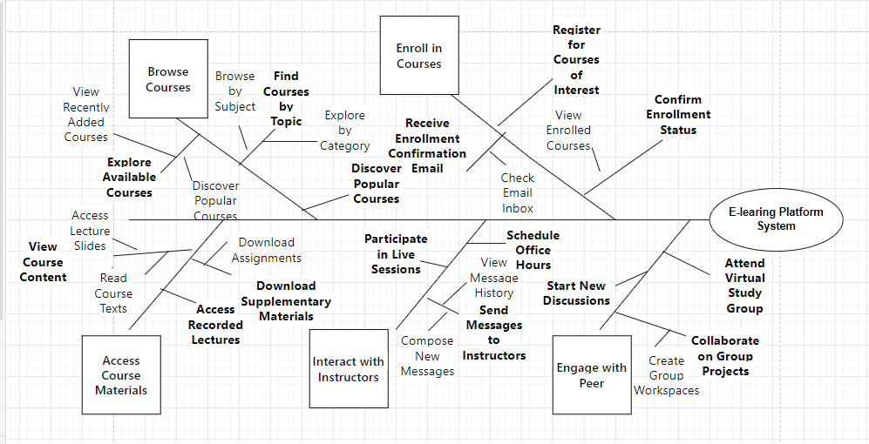

# **2.2 Scope of initial release**

**Browse Courses:** The purpose of this feature is to let users easily scan the course catalog by exploring available courses and filtering on category or subject.

**Enroll in Courses:** Students can now sign up for courses they want to take and check their registration, making the whole process of enrolling more convenient.

**Access Course Materials:** Users will still be able to download support materials and other resources in order to maintain continuity in learning.

**Interact with teachers**: Communication between students and teachers may be improved when learners engage in live sessions and chat platforms thus fostering collaboration and support.

**Engage with Peers:** Additionally, the platform will facilitate peer interaction through discussion boards as well as group projects that enhance social learning.

# **2.3 Scope Of Initial And Subsequent Releases**

|  |  |  |  |
| --- | --- | --- | --- |
| **Features** | **Release 1** | **Release 2** | **Release 3** |
| FE-1, Browse Courses | View available courses, Filter by subject or category | Discover popular courses, Explore course reviews and ratings. | Advanced search functionality, Personalized course recommendations. |
| FE-2, Enroll in Courses | Register for courses of interest, Confirm enrollment status | Receive enrollment confirmation email, Add courses to wish list. | Integration with course scheduling tools, Automated course enrollment. |
| FE-3, Access Course Materials | View course content, Download supplementary materials | Access recorded lectures, Interactive course quizzes. | Virtual lab environments, Augmented reality course materials. |
| FE-4, Interact with Instructors | Send messages to instructors, Participate in live sessions, Schedule office hours | Request one-on-one consultations, Peer review sessions. | Virtual office hours, Instructor-led webinars. |
| FE-5, Engage with Peers | Join discussion forums, Collaborate on group projects. | Attend virtual study groups, Access peer-reviewed study materials. | Social learning features, Gamification elements. |

# **2.4 Limitations and exclusions**

**LE-1**: Even if the aim of this platform is to better communication between lecturers and students, it will only allow for text based and asynchronous messaging in its first release. Real time video conferencing will not be supported.

**LE-2:** The platform’s first version will also limit data sharing and course synchronization across multiple platforms by not integrating with any external learning management systems (LMS).

**LE-3:** Personalized learning experiences are given top priority in the e-learning platform; however, there would be no adaptive learning algorithms that change automatically the contents of a course based on each learner's progress or preference in the initial release.

# **3. Business Context:**

# **3.1 Stakeholder Profiles:**

|  |  |  |  |  |
| --- | --- | --- | --- | --- |
| **Stakeholder** | **Major value** | **Attitudes** | **Major interests** | **Constraints** |
| **Students** | Learning opportunities, flexibility, certification. | Motivation, collaboration, feedback. | Course content, interaction, progress tracking | Time, technology access, learning styles |
| **Instructors** | Expertise, teaching effectiveness, professional growth | Innovation, collaboration, student-centric approach. | Course design, student engagement, assessment. | Time, technological barriers, resource limitations. |
| **Administrators** | Educational excellence, user experience, organizational efficiency. | Innovation, collaboration, data-driven decision-making | Platform development, user support, compliance/security | Budget, technical challenges, stakeholder expectations |

# **3.2 Project Priorities:**

|  |  |  |  |
| --- | --- | --- | --- |
| **Dimension** | **Constraint** | **Driver** | **Degree of freedom** |
| **Feature** | Technical limitations on course management | Need for effective course organization. | Flexibility in prioritizing features. |
| **Quality** | Budget constraints on progress tracking. | Desire for accurate progress tracking. | Adaptability in resource allocation. |
| **Schedule** | Time limitations on communication tools. | Market demand for communication tools. | Agility in adjusting timelines. |
| **Cost** | Budget restrictions on assessment. | Maximize value within budget. | Flexibility in resource allocation. |
| **Staff** | Limited skilled professionals for certification. | Leveraging skilled professionals for certification | Freedom in assembling skilled team. |

# **3.3 Deployment Considerations:**

When integrating an e-learning platform with online commerce capabilities, there are several factors that need to be considered. Primarily, a large number of users should not affect the speed of the platform. In addition, it has to have a robust security system so that users’ data and content can be protected. Moreover, it also needs to blend well with various payment options and systems. Moreover, it is important for it to adapt culturally and linguistically as much as possible. Additionally, any user including disabled ones ought to find its use easy. Lastly but not least important is for it not only be able to function over a myriad of devices but also work on different internet connections without experiencing some technical glitches . If these things are addressed, then the platform will deliver good services towards all users.